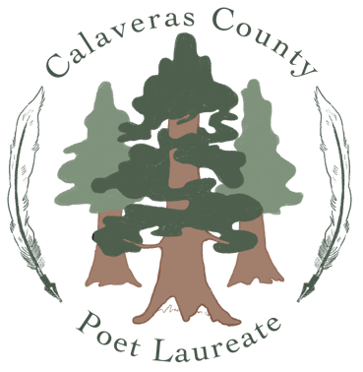
Community-Sourced Poems

From: Linda Toren, Poet Laureate Calaveras County 2022-2024

I am pleased to announce a poetry project that will feature a community-sourced poem for each district in our county.

What is a community-sourced poem (also called a crowdsourced poem)?

A crowdsourced poem is created entirely from words submitted by the public on a particular topic or theme. This project will be done by email. It will take place over a number of weeks. Once all the lines and words have been collected, I then cut up and combine these words into a new crowdsourced poem.

Theme: Celebrate features of your district and/or why you live here.

Submissions can be a short narrative, a phrase, a word, or short poem.

Send submissions to calaveraspoet@gmail.com or drop off at your local branch library.

Include your name (which indicates permission to use your name when the poems are presented to the public. INCLUDE YOUR DISTRICT. You may be anonymous if you wish.

Name:__________________________________________

District (circle one): 1 2 3 4 5

Write your submission below and return to your local library branch.

