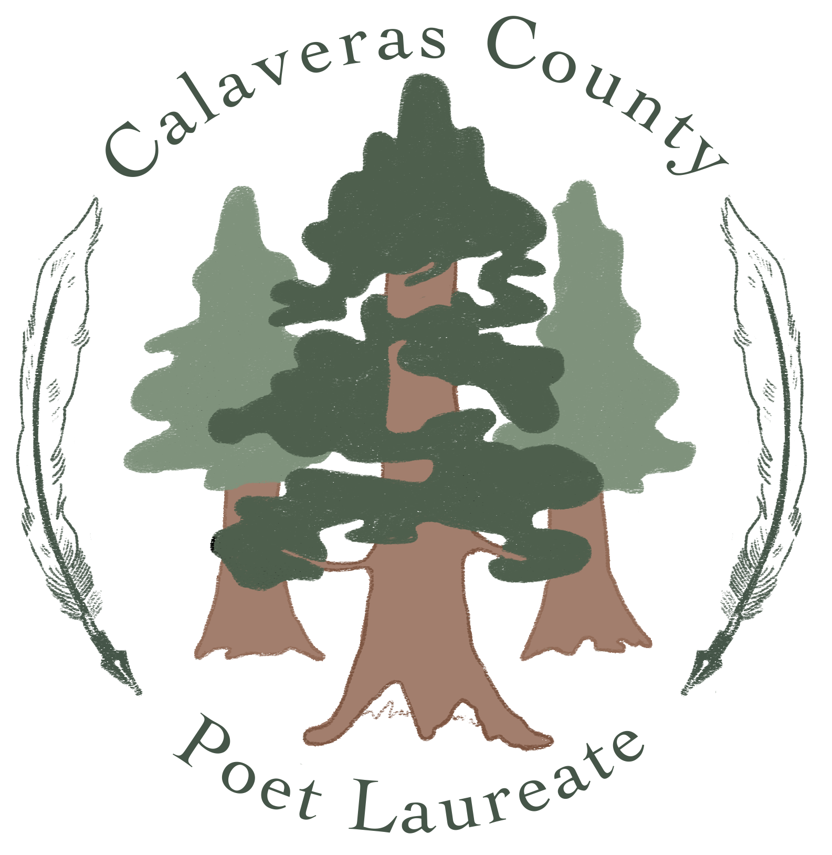
Calaveras County Poet Laureate 2024
APPLICATION FORM

First & Last Name _________________________________________________________
Professional name (if different from legal name) _________________________________
Mailing Address ___________________________________________________________
Street Address (if different) _________________________________________________
City ______________________________________ Zip Code _____________________
Daytime Phone _____________________ Evening Phone ________________________
Date of Birth ________________________
E-mail ___________________________________________________________________
Website___________________________________________________________________
Social Media addresses:
Facebook/Instagram/Twitter/Other (name): Please list in order of preference:

Current residency in Calaveras County began in (state year) ___________________

Poet Laureate 2024 – Application Form 1
Statement of Eligibility
Please document your eligibility by circling Yes or No in response to the following questions:

Y N I am at least 22 years of age.
Y N I am actively working in the field of poetry and have been published and/or recognized for my contributions.
Y N I am the single creator of the work/s submitted for review.
Y N I have not served as a member of the Calaveras County Library Commission or Friends Calaveras County of the Library in the past year.
Y N I am a current resident of Calaveras County for the past three full years.
Y N I am physically and emotionally able to carry out the duties of a poet laureate, which includes providing one’s own transportation and materials, utilizing one’s technology skills, and demonstrating communications expertise.

If you answered “no” to any of the above criteria, you are NOT eligible to serve as Calaveras County Poet Laureate.
I certify that I meet all eligibility requirements listed in these guidelines, and that all the information in this application and its attachments is true and correct to the best of my knowledge, and that I have submitted a complete application.

Applicant’s Signature ____________________________________ Date _____________

Poet Laureate 2024 – Application Form 2

