Come Celebrate
Week with Us
On Wednesday May 3rd
2:30 – 4:00 p.m.
Arnold Branch Library
1065 Blagen Rd.
Arnold, CA

Join us for a fun afternoon of activities, prizes, and a very special Dark Side guest appearance.
Sponsored by the Arnold FRIENDS of the Library
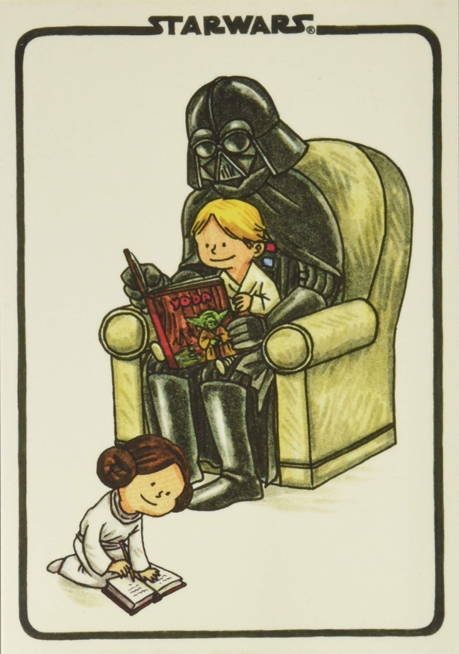
All Ages Welcome

