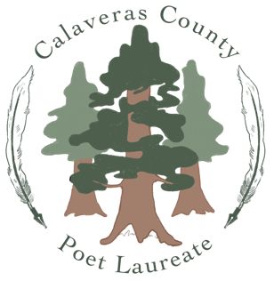

Poet Laureate Agreement

This AGREEMENT entered into this ____ day of (month), 2024 between Calaveras County Friends of the Library (FOTCCL) and ____________________________________________________________.

WHEREAS, the parties hereto desire to enter into this Agreement to define and set forth the terms and conditions of the Poet Laureate.

NOW, THEREFORE, in consideration of the mutual covenants and agreements set forth below, it is hereby agreed by FOTCCL and the Poet Laureate as follows:

- Position: Employment Period

- FOTCCL hereby employs the Poet Laureate who agrees to serve in such capacity, for the period beginning June 1, 2024, and ending on May 31, 2026.

- Background check required (FOTCCL) because of the public nature of this position. Also because of possible work in schools and libraries.

- Performance of Duties

- Inauguration presentation to BOS.
- One activity at each branch (8 branches) in a fiscal year.
- Activities for National Poetry Month each April.
- Annual presentation (state of the art) to BOS.
- I will incorporate technology use and social media into my communications plan.
- I understand I will fulfill the duties I have proposed to the best of my abilities.
- I will coordinate with library personnel for programs and workshops.
- I will maintain an appropriate public presence befitting a poet laureate.
- I will not use my position to advocate for any political statement or endorsement (as stipulated in the non-profit guidelines).

- Compensation
An annual stipend of $500 is available for travel and material expenses to be invoiced to Calaveras County Friends of the Library.

- Disability
If it is not possible to fulfill the duties of Poet Laureate as required due to illness or other debilitation, I will promptly notify Friends of the Library so that they can appoint a replacement.

________________________________________ __________________
Poet Laureate Signature Date

________________________________________ __________________
President Friends of the Calaveras County Library Date

